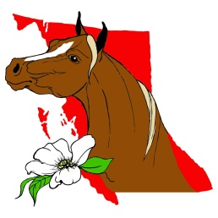 | BRITISH COLUMBIA MINIATURE HORSE CLUB  miniaturehorsesbc.com  Ray Kramer President Leona Alcock Vice President Tina Harrison – Secretary Cherie Kramer Treasurer  604-240-0626 604-533-1168 604- 240-062 myminis1958@gmail.com tinhar@telus.net myminis1958@gmail.com
SPRING CLASSIC SPONSORSHIP FORM for 2025

BCMHC Member: _______________________________________

(Please fill out form and make sure everything is provided and return it to address below)

Sponsor’s name as it should appear on the Class List: __________________________________________________________________________________________________________________________________________________________________________________________

Sponsor’s address & PC _________________________________________________________________________

Contact Person’s e-mail _________________________________________________________________________

Contact Person’s phone ________________________________________________________________________

______ BRONZE SPONSOR Class Sponsor @ $25 per class # of Classes Sponsored: ___________

______ SILVER SPONSOR Show Sponsor @ $175 Please provide 2 business cards ____

______ GOLD SPONSOR Club Sponsor @ $250 Please provide 2 business cards ____

______ I have no preference as to which classes I sponsor

______ I would like to sponsor class(es) # _________________________________________________
(Classes are allocated on a first come basis)
__________________________________________________________________________________

SILENT AUCTION SPONSOR Items ______________________________________________

__________________________________________________________________________________
(Please provide 2 or 3 business cards for the auction table and our files)

Please make cheques payable to BCMHC and give them to the member who is getting your sponsorship or
send your Sponsorship cheques to: BCMHC c/o Cherie Kramer 4416 Lefeuvre Rd, Abbotsford,BC V4X 1N8
604-240-0626 email: treasurerbcmhc@gmail.com

