PREMIUM LIST

BC MINIATURE HORSE CLUB 9th ANNUAL SPRING AMHR SHOW

AMHR APPROVED SHOW

CHILLIWACK HERITAGE PARK
44140 LUCKACUCK WAY
Chilliwack, BC

DATE: JUNE 11, 2023

JUDGES
Margo Hepner-Hart, Washington
Paul Tarap, California

SHOW STEWARD

Nanette Read

Classes start at 8 AM Sunday
Show Manager Rinda Pullen Contact at horseshowmanager@hotmail.com
For more information contact Tina Harrison 604-533-1168 e-mail tinhar@telus.net

SHOW STAFF

Show Manager ……………………………………………………………...… Rinda Pullen Show Coordinator ………………………………………Tina Harrison/Taylor Josiassen Ring Steward ……………………………………………………………………. Cassandra Lollie
Show Steward .……………………………………………………………… Rob Crater
Whipper-In ………………………………………………………………………. Faye Christie
Announcer ………………………………………………………………….……. Glen Massey
Measuring …………………………………………………………………….. Nanette Read
Barn Manager ………………………………………………………………. Leona Alcock
Ribbons & Awards …………………………………………………..……….. Tina Harrison
Arena Set Up ………………………………………………………….……….. BCMHC Veterinarian on Call ……………………………………………………..….. Greenbelt Vet
Photograpy------------------------------------------------------------------- TBA

A special thanks to all the many volunteers whose help and assistance are greatly appreciated

<<<<<<<<<<<<<<<<<<<<<<<<<<<<<<<<<<<<<<<<<<<<<<<<<<<<<<<<<<<<<<<<<<<<<<<<<<<<
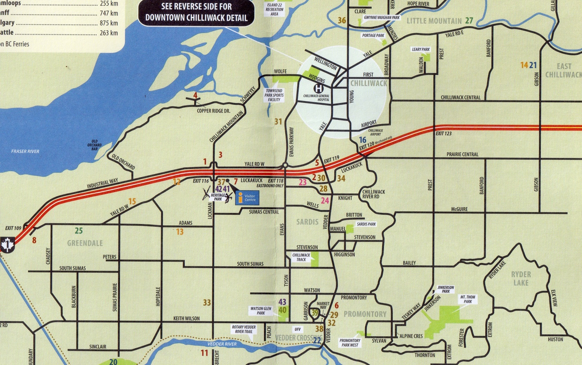

AMHR SHOW RULES AND REGULATIONS

This is an AMHR/ASPC sanctions show which is open to any AMHR/ASPC registered horse whose exhibitor is able to show proof of valid registration. Horses will be judged and classes run in accordance with AMHR rules. It is the responsibility of each exhibitor to know the rules and regulations as well as the requirements of each class entered. A copy of the official rulebook may be found in the show office. Exhibitors must provide a copy of valid registration and a copy of their amateur card (if applicable) with their entry form for each horse entered. Amateur cards are available from the show steward for $10.00 US each. Youth cards are also available from the show steward.

GATE RULE
It is the goal of the management that this show presents AHMR/ASPC horses in the best light possible, be entertaining to those who have come to watch the event, and expediently move through the class schedule for the exhibitors. EACH EXHIBITOR IS RESPONSIBLE FOR MONITORING THE PROGRESS OF CLASSES AND BEING PREPARED TO ENTER THE RING PROMPTLY WHEN A CLASS HAS BEEN CALLED WITHOUT PRIOR PUBLIC NOTICE. The gate will remain open for two (2) minutes after each class has been called to enter the ring. Horses not in the arena when the gate is closed will be eliminated from the class and the entry fee will not be refunded. Breaks have been incorporated into the show schedule for necessary tack changes and to set up equipment. Additional Gate holds not to exceed two (2) minutes requested by exhibitors, may be called at the discretion of the show manager. ALL GATE HOLDS MUST BE REQUESTED FROM THE SHOW OFFCE AT LEAST FOUR CLASSES IN ADVANCE OF THE REQUESTED HOLD.

CONDITION OF ENTRY
Every entry for this competition will be under the jurisdiction of the BC Miniature Horse Club (“BCMHC”) show management, but the BCMHC will in no case be responsible for any loss or damage that may occur. It shall be a condition of entry that each exhibitor shall hold the horse show, the BCMHC management, the BCMHC, Tourism Chilliwack Inc. and the City of Chilliwack harmless for any loss or injury to their horses or equipment which may occur from sickness, accident, fire or any other factor.

ENTRY PROCEDURE
Entries must be on the official entry forms for this show. Entry forms may be photocopied for use. All requested information must be provided for each horse entered. Forms will not be accepted unless they are complete and accompanied by the required fees and a copy of the AMHR/ASPC registration papers for all horses entered. Remember you will also need a copy of your papers to be measured. NUMBERS WILL NOT BE RELEASED WITHOUT FULL PAYMENT OF ALL FEES. NO ENTRIES WILL BE ACCEPTED OVER THE PHONE. Exhibitors are responsible for the accuracy of entry forms prepared by themselves or their agents. Gelding status must be shown on registration forms and all foals of the current year must be registered prior to the show.

POST ENTRIES – ADDING CLASSES – LATE FEES
After the closing date for entries a post entry fee of $10.00 may be assessed. Additional classes for horses entered before the deadline date may be added with no extra cost. Post entries or added classes will be accepted up to five classes prior to the class entering the ring, provided the horse is determined to be eligible for entry. Post entries made for the first five classes each day will be accepted up to one half (1/2) hour prior to the first class entering the ring. POST ENTRIES MADE DURING THE SHOW MUST BE MADE AT THE SHOW OFFICE AND WILL NOT BE ACCEPTED UNLESS ACCOMPANIED BY FULL PAYMENT. Management reserves the
right to accept entries for unfilled classes after the closing date at the regular fee. There will be a $50.00 charge for all cheques returned for lack of funds. This must be paid before entry numbers are issued at this or any following show.

SCRATCHED CLASSES – REFUNDS
No entry fees will be returned without a Veterinarian’s Certificate as to the unsoundness of the entered horse. This must be presented to the show secretary before the first class of the day. Failure to show a horse that has been entered constitutes a forfeiture of entry fees. In the event of sudden illness of a horse after the entry deadline, the exhibitor may substitute another animal at no extra charge. If done at the show it must be done within the time frame outlined in the Post Entry section. Refunds will be mailed to exhibitors after the conclusion of the show.

AWARDS
All classes have ribbons to 6th place. Exhibitors will have the option of choosing to keep their 1st to 6th place ribbons or to exchange them at the gate for a token redeemable for $0.50 at the show office at the end of the show.

MEASURING
All horses shall be measured in accordance with AMHR/ASPC rules. If your horse has a current measurement card or has been measured within the last sixty (60) days, please submit a copy of the card with your entry. All horses will be measured by the show steward with an official certified AMHR/ASPC measurement stick and all horses at the show will be measured with the same stick. REGISTRATION PAPERS and other necessary paperwork MUST be presented to the Show Steward for each animal entered at the time of measurement. All measuring will take place on the show grounds in a designated area. MEASURING WILL BE SATURDAY
JUNE 10TH FROM 6:00 PM UNTIL 8:00 PM and Sunday JUNE 12TH FROM 7:00 AM UNTIL 8:00 AM.

SCHEDULE OF SHOW FEES
Youth Class entry fee $15.00 per class Stakes Class fee $35.00 per class
All other Classes $25.00 per class
Stall fee $50.00 from noon Saturday to Sunday night
Stall fee $85. From noon Friday till Sunday show end
Tack room fee $30 for Saturday till Sunday or
$60. For the weekend
RV parking $35.00 per night payable on Stalling Form

NOTE SEPARATE FORM FOR STALLING AND RV PARKING FEES.
Please make all cheques or Canadian money orders payable to BCMHC, or Cash.

STABLING
Stalls will be available for Sunday only at $50.00 for horses and for tack or feed at $30.00 per stall. If stalls are required for the weekend, stalls occupied by horses will be available at $85.00 each and if occupied by feed or tack at $60.00 each for the weekend which starts at noon on Friday and ends when the show ends on Sunday. Bedding will be supplied ,but this year you will have to BED YOUR OWN STALLS WITH THE SAWDUST/SHAVINGS PROVIDED. No nails or screws NO STAPLES are to be used in or around stalls. Only clear hockey tape to be used or there will be an additional charge by the facility. Stalls will be assigned in the order that entries are postmarked. If all stalls are reserved prior to receiving your stall reservation, show management will attempt to notify you of this situation by phone prior to the show. Anyone arriving earlier than above will have to make arrangements directly with the facility. No overnight stabling Sunday night, unless by arrangement.

LUNCH AND DINNER BREAKS
No specific breaks have been scheduled in this show. Show management and judges will determine the progress of classes and announce a lunch break to occur as close to 12:00 noon as possible. A dinner break will be called if necessary.

SILENT AUCTION A SILENT AUCTION WILL BE HELD DURING THE SHOW STARTING ON FRIDAY. PLEASE BRING SOME ITEMS FOR THE AUCTION IF YOU CAN. ITEMS DO NOT HAVE TO BE HORSE RELATED. SILENT AUCTION WILL BE COMPLETED ONE HALF HOUR AFTER THE END OF THE LUNCH BREAK ON SUNDAY AND THE WINNERS ANNOUNCED.

LODGING
Travelodge Hotel 1.74 miles 800-504-588
Comfort Inn 1.60 miles 877-868-3385
Coast Chilliwack Hotel 2.81 miles 877-868-3385
Hampton Inn by Hilton 0.34 miles 877- 868-3385

RV parking with hook up is available at $35.00 per night, without hook up $20.00 per night. Please reserve on the Stalling Form.

PLEASE NOTE: ANIMAL ABUSE WILL NOT BE TOLERATED AT THIS SHOW. IF REPORTED IT WILL BE INVESTIGATED AND IF VERIFIED, YOU WILL BE DISQUALIFIED FROM THIS SHOW.

